TITLE IN ENGLISH
(Times New Roman 12 pt, BOLD UPPERCASE except species name which should be written as usual e.g. Escherichia coli)
Author1,¹ Author2,² Author3^{3,}*
(Times New Roman 12 pt; underline the presenter’s name but not the comma and number and place * (not superscripted) after corresponding author’s name; use (full) Firstname Lastname format e.g. Tirayut Vilaivan – do not abbreviate initials.)
¹Affiliation of 1st author
(Times New Roman 12 pt, include country name, without fullstop)
²Affiliation of 2nd author
(No spacing before and after paragraph)
³Affiliation of 3rd author
(Combine the affiliations that are shared by more than one authors, Do not use number if all authors share the same affiliation.)
*e-mail:
e-mail address of the corresponding author (leave a blank space after :)
(Leave a blank line between e-mail and abstract.)
Abstract:
Use Times New Roman 12 pt, symbols should be inserted by using menu Insert>Symbols (Font: Symbol 12 pt). The text should be fully justified.
(Leave a blank line between sections.)
Introduction:
A brief discussion of rationale and prior related work in the field.
(Leave a blank line between sections.)
Methodology:
Details of materials and methods, as well as experimental protocols if applicable. Sub-headings may be added, using italicized text.
(Leave a blank line between sections.)
Results and Discussion:
Show the results and discussion. Spacing before and after paragraphs should be set to 0 pt (i.e. no spacing). Indentation of the new paragraph should be set by a Tab (no autoindent and autonumber). Figures and tables may be included, which should be numbered and referred to from the text. The figure/table should be centered and the layout must be set to "in line with text" and not "square" or "tight" to ensure that the final printout will look the same as what you submitted. Free-floating, as well as pictures obtained by grouping several objects and/or texts together are not acceptable. A table should be used to arrange the positions of multiple figures. A figure caption is required, and should be placed directly below the figure in the form Figure 1. xxx and center justified.
A new paragraph should start with a tab (use default tab stop of 1.27 cm or 1"). Do not insert a blank line between paragraphs in the same section. All references must be referred to from the text by a superscripted number.¹
(Leave a blank line before and after Figures.)
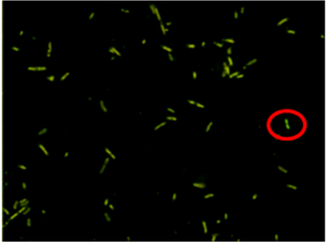 | 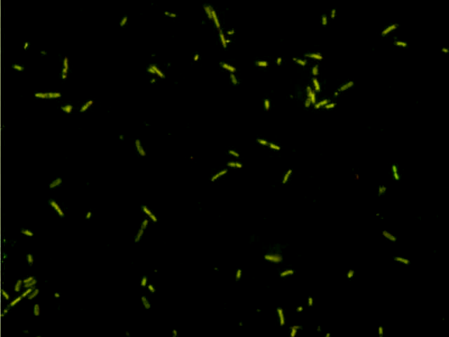
Figure 1.
Examples of acceptable figure (left) and unacceptable figure (right)
Click and drag the red circles to compare the difference.
(Leave a blank line before and after Figures.)
(Leave a blank line before and after Tables.)
Table 1.
A table example is shown below. The caption should be left-justified. The heading should be in boldface and the first letter capitalized. Use only horizontal lines in the table. Do not use space or tab to position texts within the table.
Column 1 | Column 2 (unit)ª | Column 3 (unit)^{b}
Entry 1 | 0.1 | 10³
Entry 2 | 0.2 | 10⁴
Entry 3 | 0.3 | 10⁵
ªFootnote 1
^{b}Footnote 2
(Leave a blank line before and after Tables.)
Conclusion:
Conclusion of the work.
(Leave a blank line between sections.)
References:
- Ananthanawat C, Vilaivan T, Hoven VP. Sens Actuators B. 2009;137:215–221.
All references must be numbered, left-justified and referred to from the text. Use only the standard format shown above (Lastname1 Initial1, Lastname2 Initial2. Journal abbreviation. Year;volume:page-page). Web pages, books and unpublished documents should not be used as references. Use autonumber feature in MS Word to adjust the indentation of references.
(Leave a blank line between sections.)
Acknowledgements:
(Optional, delete if not use.)

Details of template setting:
Page Layout: A4, portrait, 1" margins
Font: Times New Roman 12 pt, for Symbols use menu Insert>Symbol (Font: Symbol 12 pt)
Paragraph Style: Single line spacing and fully justified, except for title, authors and affiliations, which should be left-justified. Spacing before and after paragraphs should be set to 0 pt (i.e. no spacing between paragraphs). Do not use blank line to separate paragraphs. Indentation should be made manually by using Tab. Autoindent and autonumber features in Word should be disabled.
Other: The length of full paper should be 5-10 pages. Delete all the “red” text before saving. Save the file in Word 2003-2007 format (.doc).

